**KLondike 5-**1212

**KLondike 5-**1212

**KLondike 5-**1212

**KLondike 5-**1212

**KLondike 5-**1212

**KLondike 5-**1212

**KLondike 5-**1212

**KLondike 5-**1212

**KLondike 5-**1212

**KLondike 5-**1212

**KLondike 5-**1212

**KLondike 5-**1212

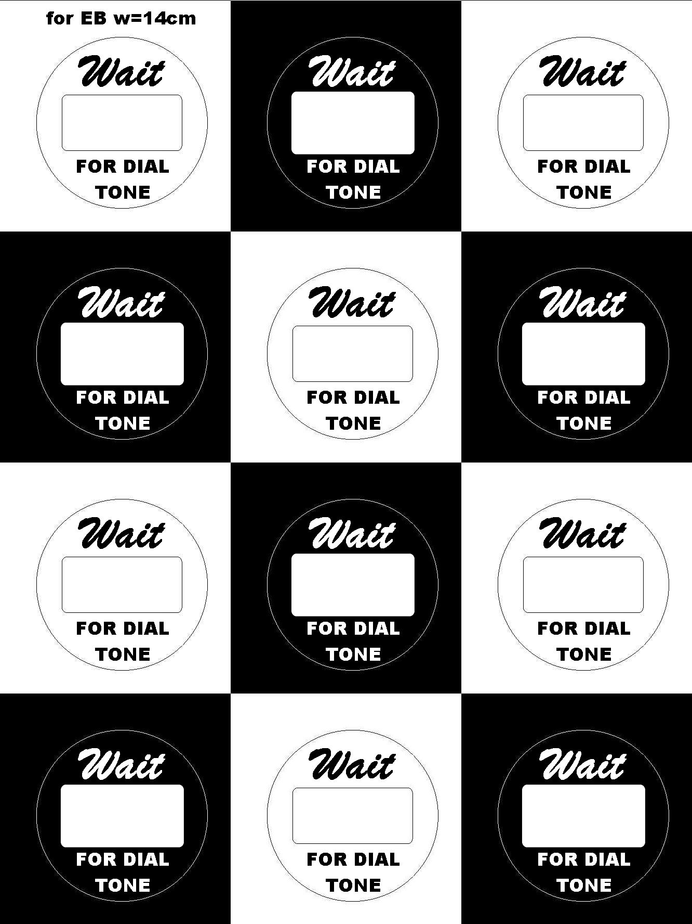

555-1212

**Area   
 700**

555-1212

**Area   
700**

555-1212

555-1212

555-1212

**Area   
700**

555-1212

**Area   
700**

**Area   
 700**

**Area   
700**